Now let's look at deleting internal tables where we are using word carriers. Word carriers are fundamentally different structures that we set up in our program. Therefore, when we write some code that affects the internal table, it will never affect the work area at the same time. And the reverse is true.

Whatever code we write that affects the work area structure will never affect our internal table. When we're using internal tables with no header lines, some of the statements we've just been through will work a little bit differently.

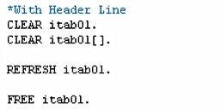

The clear statement, when used on a table without a header line, clears the whole table contents.



We saw it make sense because I specified, make sure you clear the header line, then you clear the table contents. But the syntax will work a little differently here. if I say, with header line here and show the differences with work area, so here to clear out the table we would use this thing.



CLEAR then the table name. We don't need the square brackets. But then, we've got to keep in mind our work area is separate, so we must clear that out as well. So, all you need to do is use the CLEAR statement again and then specify your work area.



We would have REFRESH itab01 to clear out the table, which is the same as with the header line. But you've got to remember, treat your work area differently because it's a different structure.



FREE statement will clear the internal table from memory and then we would have to separately clear out our work area.